POSTPONED
Due to current Covid 19 restrictions this event has been postponed until further notice.
Weed identification & management Field Day.

The Goomalibee landcare group and Benalla Rural City Council will be hosting a weed identification and management field day. Come along and gain a fresh insight from a local agronomist on the weeds affecting private and public land, learn more about how to identify weeds, control measures and soil management. Bring along your own samples and we will help you identify it. (Please bring all samples in sealed bag)

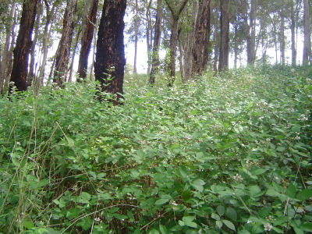
Date: Postponed until further notice.
When: Arrive at 9:30 am with the event expected to run through till noon.
Location: 600 Tarnook rd, Tarnook, Victoria 3670.
RSVP:
4:00 pm Wednesday the 21st of July.
Due to current COVID 19 requirements, registration is mandatory to attend this event.
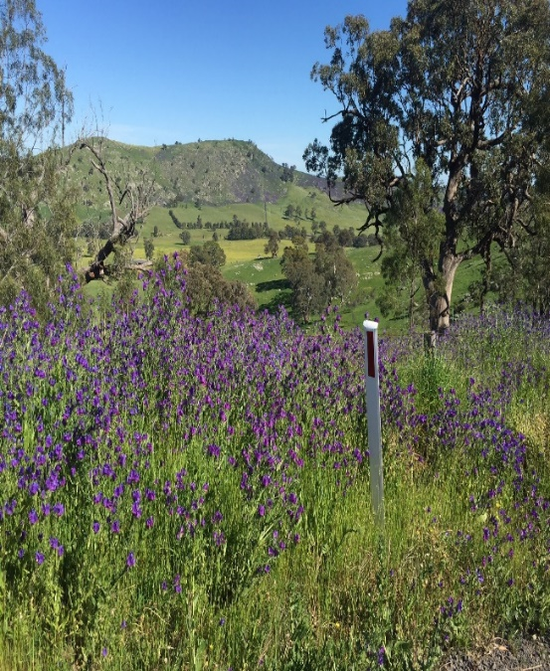
If you are feeling unwell or awaiting the results of a COVID 19 test, please do not attend.
For further information please contact
Amanda McLean on 0400 610 907
Email: amclean71@hotmail.com or
Jonathan Sacco Email: geckoprojects@outlook.com
On the day, please bring along a drink bottle and wear suitable clothing for a paddock walk. The event will start with a presentation and a chance to identify local weed samples followed by a walk in the paddock.

