Can Dung Beetles work for you?
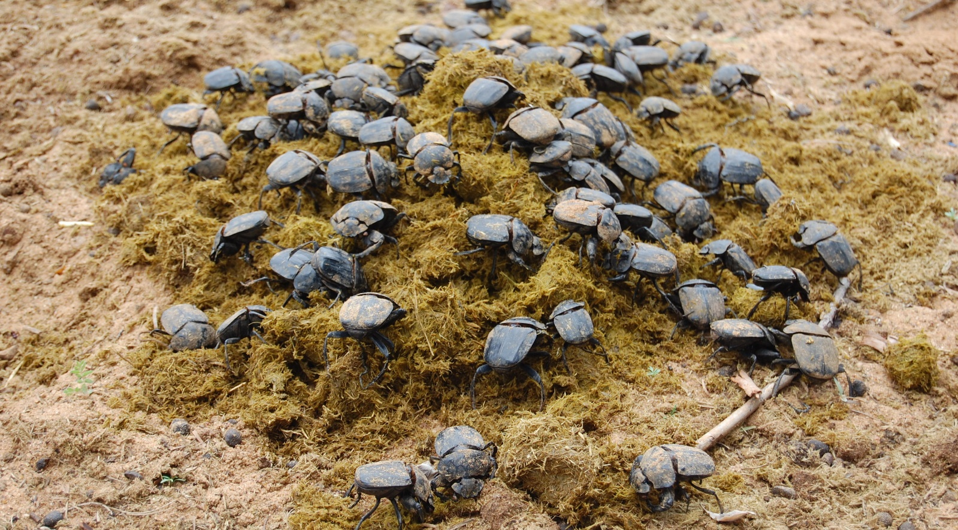
Longwood East Landcare invites you to attend a free event
The talk will cover the use of dung beetles, including
- What they are and how they work
- Which beetles will suit your livestock
- How dung beetles assist with soil compaction
- Identifying your current beetles (if you bring a sample)
Bring your boots – some walking will be involved.
Attendees will go into a draw to win a $600 dung beetle colony.
Date: Saturday 16th September, 10:00am to 12:00pm followed by BBQ.
Location: 231 Longwood-Ruffy Road, Longwood East.

Places are limited. You must RSVP to Gayle Shapcott by 8th September if you want to attend.
Email: gayleshapcott@hotmail.com
Phone: 0412 354 426

This project is supported by the Goulburn Broken Catchment Management Authority’s Beyond SoilCare program through funding from the Australian Government’s National Landcare Programme.

