Unlock your farm business potential
Inspiring short course for farmers and land managers – learn key decision making tools to achieve success for you, your business and your environment.

Expression of Interest Form

Places are strictly limited in the Holistic Management short course. The course is open to farmers, land managers and community members from the Goulburn Broken Catchment. People from outside the catchment are welcome to apply but priority will be given to those from within the catchment. To submit an expression of interest (EOI), please complete your contact details and the questionnaire below.

Places are available for 20 successful applicants. Course fees are $650 per person (normally valued at $2,000), which covers:
- Workshops over eight days
- Morning tea, lunch and afternoon tea
- Networking dinner (excluding drinks)
- Course notes, guides and planning templates.
Please note that course fees do not include accommodation or travel costs to Shepparton to attend the course.

EOIs should be submitted to the Goulburn Broken CMA by 10 am Monday 5 September 2016 by emailing ashleyr@gbcma.vic.gov.au or posting to PO Box 124, Benalla VIC 3672. Successful applicants will be notified by Tuesday 27 September 2016.

For further information please contact:
Ashley Rogers, Goulburn Broken CMA by phone 03 5764 7507 or email ashleyr@gbcma.vic.gov.au.

Personal Details

Title: _______First Name: _____________________ Surname:_______________________________________

Postal Address: _______________________________________________________________________________________________
_______________________________________________________________________________________________
_______________________________________________________________________________________________

Phone: __________________________________

E-mail:_________________________________________________________________________________________

Occupation: ____________________________________________________________________________________

Industry: _______________________________________________________________________________________

Age: ______________

Please circle the highest level of education you have successfully completed:

High school TAFE Undergraduate University Postgraduate University

Dietary requirements (for catering purposes): ________________________________________________________________

Expression of Interest Questionnaire
- What skills are you seeking to learn by undertaking this course? Please give an example of how these skills would be applied to your farm business and/or job (in less than 100 words).

- Can you tell us about any training or learning experiences you have participated in the last two years and how it has benefitted you and/or your farm business (in less than 100 words)?

- Describe your current farm business or property in terms of enterprises/products, size, years of operation, issues and vision (in less than 100 words).

- Are you a farmer, land manager or community member in the Goulburn Broken Catchment? Please place a cross on the area where you farm or work on the map.

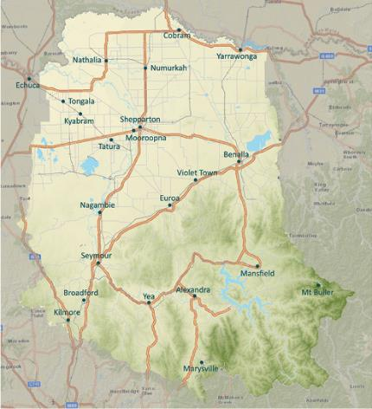
Map of Goulburn Broken Catchment

- Are you able to attend all the workshops and functions? Yes / No (please circle)
If no please give details:

Acceptance
I can attend all the sessions, including dinners and I am committed to actively participate in all activities.

Signed: ____________________________ Date: ____________________

