Kickstart your future in agriculture
Accredited short course for young agribusiness professionals

Expression of Interest Form

Places are strictly limited in the ‘Kickstart your future in agriculture’ intensive short course. The course is open to 18-35 year olds working in agriculture from the Goulburn Broken catchment. People from outside the catchment are welcome to apply but priority will be given to those from within the catchment. To submit an expression of interest (EOI), please complete your contact details and the questionnaire below.

Places are available for 25 successful applicants. Course fees are $285 per person (normally valued at $2,850), which covers:
- Workshops over four days
- Morning tea, lunch and afternoon tea
- Networking dinner (excluding drinks)
- Course notes, guides and planning templates.
Please note that course fees do not include accommodation or travel costs to Euroa to attend the course.

EOIs should be submitted to the Goulburn Broken CMA by 10 am Monday 18 July 2016 by emailing ashleyr@gbcma.vic.gov.au or posting to PO Box 124, Benalla VIC 3672. Successful applicants will be notified by Friday 22 July 2016.

Personal Details

Title: _______First Name: _____________________ Surname:_______________________________________

Postal Address: _______________________________________________________________________________________________
_______________________________________________________________________________________________
_______________________________________________________________________________________________

Phone: __________________________________

E-mail:_________________________________________________________________________________________

Occupation: ____________________________________________________________________________________

Industry: _______________________________________________________________________________________

Farm Business Name (if applicable): _________________________________________________________________

Age: ______________

Please circle the highest level of education you have successfully completed:

High school TAFE Undergraduate University Postgraduate University

Dietary requirements (for catering purposes): ________________________________________________________________

Expression of Interest Questionnaire

- Describe your current agricultural business or business idea in terms of enterprises/products, size, years of operation, issues and vision (in less than 100 words).

- What skills are you seeking to learn? Please give an example of how these skills would be applied to your agricultural business and/or job (in less than 100 words).

- Can you tell us about any training or learning experiences you have participated in the last two years and how it has benefitted you and/or your agricultural business (in less than 100 words)?

- Describe one or two community groups or professional organisations you belong to and why they are important to you and your agricultural business (in less than 100 words).

- Are you a young farmer or agribusiness professional (18-35 year old) in the Goulburn Broken catchment? Please place a cross on the area where you farm or work on the map.

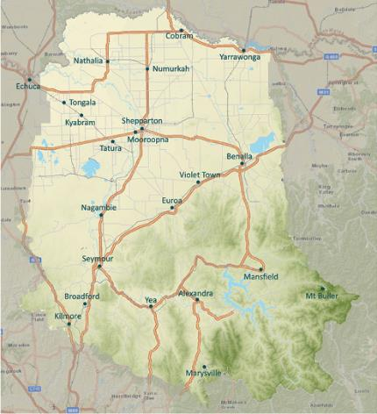
Map of Goulburn Broken Catchment

- Are you able to attend all the workshops and functions? Yes / No (please circle)
If no please give details:

Privacy Statement
Please read this information carefully before signing below:

The Goulburn Broken CMA and 4 Up Skilling Pty Ltd (TOID 32141) may use the information collected on this form for the following purposes:
- Expression of Interest information collected in connection with applicants for work; and,
- Information obtained to assist in managing client and business relationships.
We may disclose your personal information for the purpose for which it is primarily held, or for a related secondary purpose. In some cases we may only disclose information with your consent.

Personal details will not be added to any mailing list, used for marketing purposes or shared with any third party without your consent.

For information regarding our compliance with the Privacy Act please ask our staff for a copy of our Privacy Policy.

Acceptance
I can attend all the sessions, including dinners and I am committed to actively participate in all activities.

Signed: ____________________________ Date: ____________________

What happens now?
EOIs will be accepted until 10 am Monday 18 July 2016. They will then be reviewed by the project team with successful applicants notified by Friday 22 July 2016. Successful applicants will receive the full program details and are required to accept their place and pay the $285 (including GST) course fee by Friday 5 August 2016.

For further information please contact:
Ashley Rogers, Goulburn Broken CMA by phone 03 5764 7507 or email ashleyr@gbcma.vic.gov.au.

