**Attracting Wildlife to Your Garden**

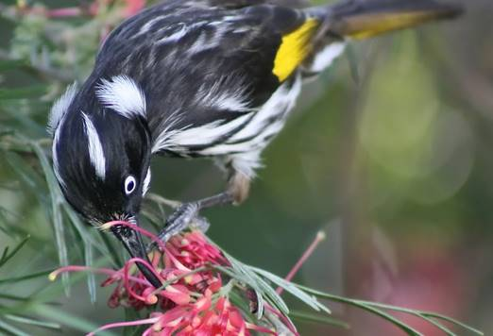

**Longwood East Landcare Group invites you to a FREE event**

**Did you know that the turquoise parrots’ nest in the hollows of tree stumps, that firetail finches prefer to nest in a prickly habitat, that black cockies go nuts for hakea's and that the Wood White Butterflies love Mistletoe?**

**Find out so much more when Cathy Olive, Project Manager from the Euroa Arboretum talks about our local and transient wildlife, their habitats, preferred food and how to attract them to your patch through indigenous and native plantings. This will be followed by a guided walk through the arboretum and a BBQ.**

**Attendees (one per property) will receive a free membership to the Euroa Arboretum's "Garden for Wildlife" program which includes a pack of 6 plants and booklet on sustainable gardening and discounts on Arboretums future events. (Valued at $20)**

**Date: Saturday 8th September, 10:00am**

**Location: Euroa Arboretum picnic area, 76 Euroa Main Road, Euroa**

**2 hour workshop followed by BBQ. Please bring chair**

**Places limited, please RSVP by 3rd September.**

**Email:** [**gayleshapcott@hotmail.com**](mailto:gayleshapcott@hotmail.com)

**Phone:            0412 354 426**

Description: Description: Description: Description: cid:image002.jpg@01C92873.C75F9550This project is supported by the Goulburn Broken Catchment Management Authority

|  |
| --- |
|  |
|  | cid:image010.png@01D4397D.153E59D0 |